Installation of Xilinx Vitis is time consuming, you will need around 3 hours to start and complete the install, please plan ahead.

1. Goto: <https://www.xilinx.com/support/download.html>
2. Click on the Vitis (SW Developer) tab
3. Scroll down and click on the link:

AMD Unified Installer for FPGAs & Adaptive SoCs 2023.1: Windows Self Extracting Web Installer

1. Sign in or create an account and then click red Download
2. Open the self-extracting archive
   1. Read information on Welcome screen, click Next

* 1. Provide login information (same as used to download software). Select Download and Install Now radio button. Click Next.

* 1. Product to Install: Vitis - this will automatically install Vivado as well.

* 1. Select the following options:

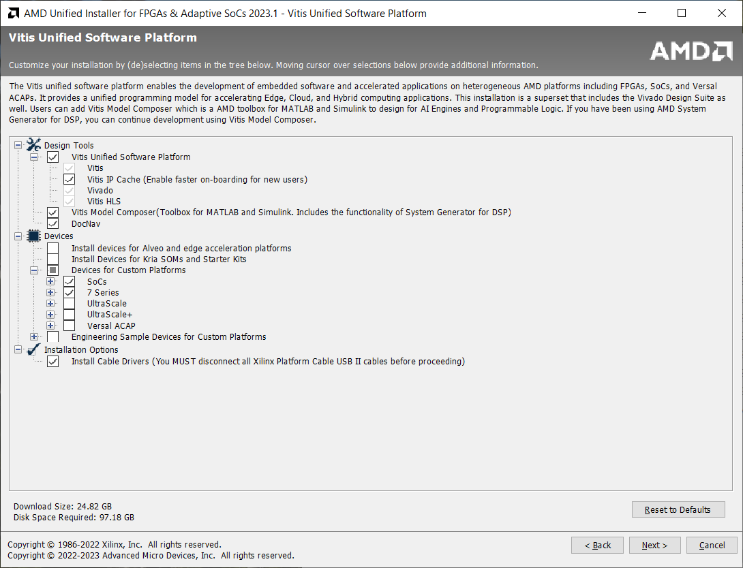

* 1. License Agreements: Scroll down and agree to all of them.

* 1. Put Xilinx in the root directory of your preferred (biggest) drive.

* 1. Click Install.

* 1. A few hours later…

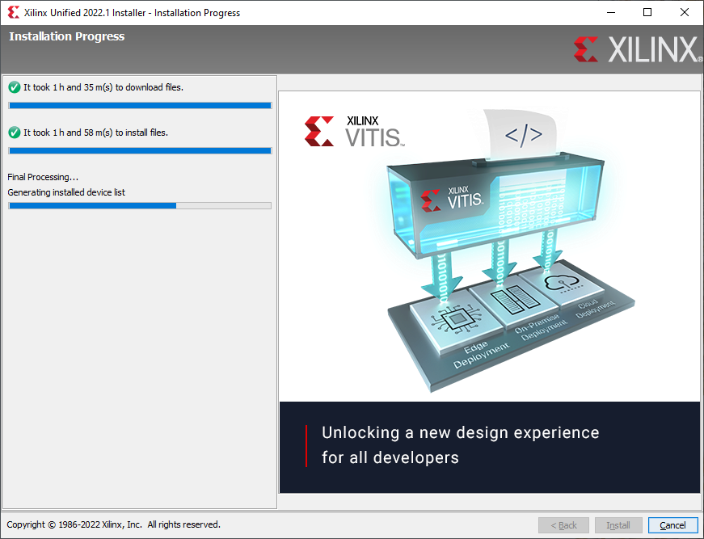

* 1. After this, you should be all set to go.

**Potential Installation Issue**

If you are running Windows and get an error saying that VCOMP140.dll was not found when opening Vitis/Vivado you may be missing a component of the Visual Studio 2015 redistributable. To resolve this error, install the Community Edition of Visual Studio 2022 and add the MSVC 2015 component, like shown in the below image. The other stuff checked is only important in case you want to do C/C++ development with Visual Studio.

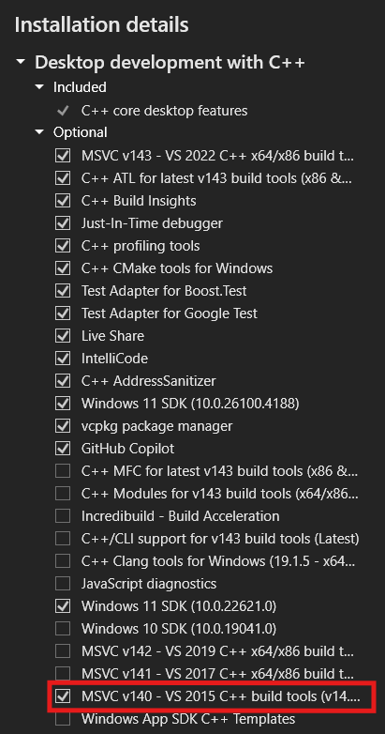

 For students running Linux, they need to make sure that they run the script /tools/Xilinx/2025.1/Vivado/scripts/installLibs.sh once completing the normal installation process. This should get output over stdout/stderr when students run the installation executable. It looks like students need to use a supported OS to get Vivado to work. Would recommend using Ubuntu.